Practice AP Questions due 1/12/16

Please time yourself and record how long the following two problems take you with a graphing calculator:

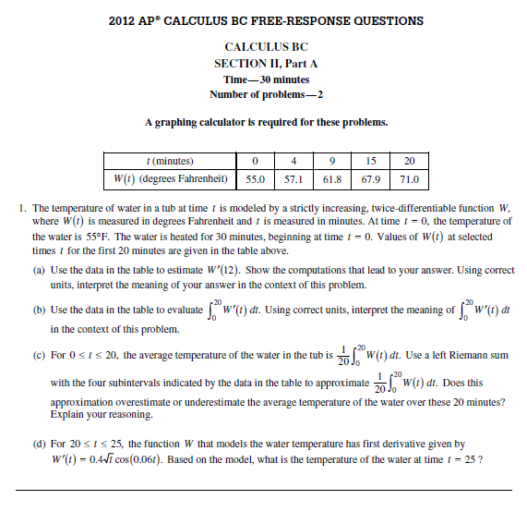

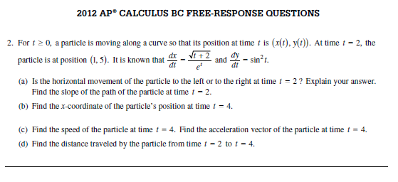

For the next part, there should be one more question, but we have not covered it yet. Therefore, try to complete the next three questions in about 45 minutes and record your time WITHOUT USING A CALCULATOR:

